21 April 2017

SAP Solution Manager 7.2 Value

As the pace of business continues to accelerate in our digital world, IT departments must stay agile and competitive you have to meet changing or growing business requirements. Besides keeping back-office systems running, you need to invest into new functionalities, innovative technologies and enhanced capabilities. As the pressure to turn IT into a **strategic value realization** centre intensifies, SAP Solution Manager helps you measure value realization, letting you review comprehensive metrics to identify opportunities for process improvement. You can become a **full partner in strategizing** for business innovation by linking the customers to the **strategic KPIs** in productive software solution, building what the business needs when it needs. You can rely on SAP Solution Manager for proactive system and application monitoring, and you can manage innovation projects from start to finish, from gathering requirements to deploying the solution. You keep landscape, process performance and project progress visible to all stakeholders, providing one up-to-date single source of the truth that improves decision making of IT executives, team leads, architects and subject-matter experts.

Solution 
Manager 
Transparency 
Efficiency 
performance 
Consi stency 
Stability 

SAP Solution Manager is a **state-of-the-art** management platform to derive maximum value from your **SAP support engagement**. The new release SAP Solution Manager 7.2 is designed not only to support you managing your existing IT landscape, but also to facilitate the delivery and adoption of breakthrough **innovations** and optimize the value of **digitization** provided by **SAP S/4HANA** while increasing the efficiency of operations: all the best practices and agile methodologies developed through more than 40 years of experience helping customers succeed.

Reducing manual effort and cost plus introducing new business functionality in a single interface, SAP Solution Manager has evolved into a full software and services management tool that helps our customers centralize and streamline management of **end-to-end** business processes (define requirements, track projects, manage testing, control change, and orchestrate services), even in **hybrid cloud and on premise** landscapes and environments with a high number of installed **SAP and non-SAP** software systems and therefore dramatically reduces the cost of operations.

...from complex ALM point solutions... 
...to an integrated and holisticALM approach... 
to 
Run 
Build 

The SAP Solution Manager Product Management team was in Australia last month, and Rajeev Gollapudi has been interviewed during his visit in Sydney. During a Questions & Answers session, he highlighted 5 main values for Solution Manager 7.2:

1. [Process Management](http://www.bluepencil.com.au/single-post/2016/10/31/More-than-a-Process-Management-tool): it has been developed from the scratch, you do not need an external tool to design your business processes.
2. User Experience: all user tasks and access are via web interface based on SAP UI5, and SAP Fiori apps are available to make it easier. It also provides a flexible dashboarding functionality that offers role-specific access through an attractive interface with drill-down capability. Even beginners can manage the wealth of features step by step, experimenting with the easiest and most relevant first.
3. HANA Supportability: now it can be installed on top of HANA database, and no license costs.
4. Cloud Operations: it supports all you on premise, cloud and hybrid implementations, helping you optimize the value of applications throughout their entire lifecycle.
5. [Project Delivery](http://www.bluepencil.com.au/single-post/2016/11/24/Project-Management-on-SAP-Solution-Manager-72) (R2D): it covers end-to-end requirement to deploy process:
   * higher automation for transport management (dependencies and requirement tracking),
   * transparency and up to date project status for the PMO through the new dashboards,
   * jump-start the project (best practices, roadmaps, project plan templates),
   * fully support for agile methodology,
   * centralised task management across global teams.

Design 
Asses 
delWy 
Enhance 
Innwate 
The requirement-to-deploy 
value chain supports the 
No overhead. 
three different change paces 
at an optimum. 
solutbn 
nent 
s cha ngæ 
De liv 
Test 
d8iy 
ntti8tive far 
solutbn 
De 
Deplß' 
As fæt —ded 
in 
Monitor Solution Readness 

Extending the list above, we can include 2 key components for the **IT Governance**:

1. [Test Suite](http://www.bluepencil.com.au/single-post/2016/11/02/Test-Management-on-SAP-Solution-Manager-72): SAP Solution Manager helps ensure successful go-live and stable production operations without jeopardizing time to value for innovations. This tool makes your testing both thorough and cost-effective, taking advantage of [component-based test automation](http://www.bluepencil.com.au/single-post/2017/01/11/Test-Automation-CBTA-on-SAP-Solution-Manager-72) and applying smart filtering to identify relevant test cases. SAP Solution Manager includes a [business process change analyser](http://www.bluepencil.com.au/single-post/2016/11/24/Change-Impact-Analysis-with-BPCA) that helps you identify critical business processes affected by planned changes. You can develop [impact analyses for changes](http://www.bluepencil.com.au/single-post/2017/01/11/Technical-Bill-of-Material-TBOM-and-BPCA) resulting from new or updated customizations or planned business function activation, focusing on the key processes and avoiding unnecessary testing activities.

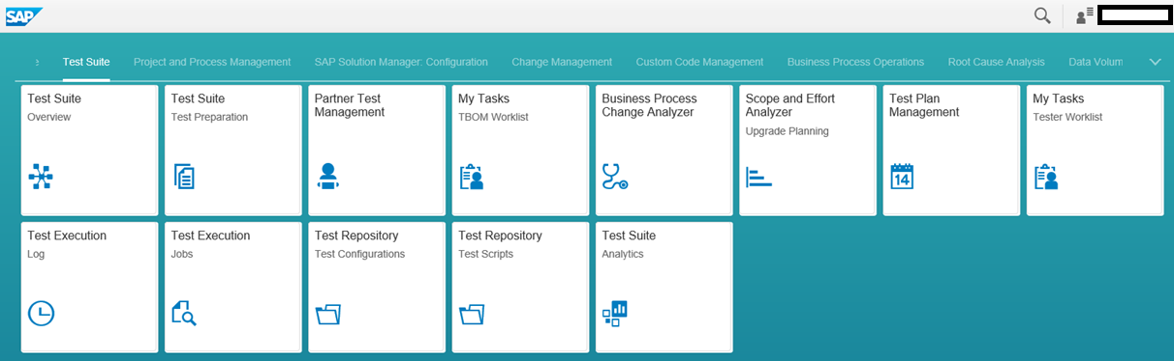

1. [Change Control Management](http://www.bluepencil.com.au/single-post/2016/11/03/Change-Control-Management-in-SAP-Solution-Manager-72): Controlling changes in your landscape and its processes change management functionality in SAP Solution Manager maintains consistent high-quality control of change, from ad hoc deployments to full-blown new releases, in on premise, cloud, and hybrid environments, across all groups in your entire organization. One central change management tool covers all [development systems and technologies](http://www.bluepencil.com.au/single-post/2016/11/24/Change-and-Transport-System-CTS-and-Enhanced-Change-and-Transport-System-CTS) and orchestrates implementation and tracking of changes in full compliance with the rules of the Information Technology Infrastructure Library (ITIL). The tool also automatically notifies affected users and updates your existing solution documentation in production after you apply changes.

We can monetise the SAP Solution Manager value accordingly your scenario. If you need help to build a business case for your company, please do not hesitate to contact us.

F actor Size and / orComplexity 
Custom Code Management 
Business Process Change Anab,zer 
Change Control Managenert 
Retrofit in Change Contol M anagenent 
Service Desk Managemert 
Test M anagenent 
Test 
Business Process Docunentation 
Data Volune M anagenent 
rmnetary value: Totals vath Size S to L 
OamageLevel: 
Business Process Monitoring 
Totals: Sizes to L +0amageLevel 
120,000 € 
2,200 € 
1,100€ 
1,100€ 
27,000 € 
7,200 € 
10,600€ 
169,200€ 
10,800€ 
180,000 € 
reduced and value realized. 
360,000 € 
22,000 € 
11,000€ 
59,000€ 
18,450€ 
87,000€ 
270,000 € 
60,000 € 
26,500€ 
Average 
342600 € 
600000 € 
132,800€ 
66,000 € 
354,000€ 
147,000€ 
87,000 € 
192,000€ 
79,700 € 
Worst 
858,500 € 
These examples show possible areas where costs can be 
should give the custorner an orientation about cost saving potential with SAP Solution 
It isa first value hypotheses and 
Manager. 

--

Jacques K. Maeda

[www.linkedin.com/in/jkmaeda](http://www.linkedin.com/in/jkmaeda)